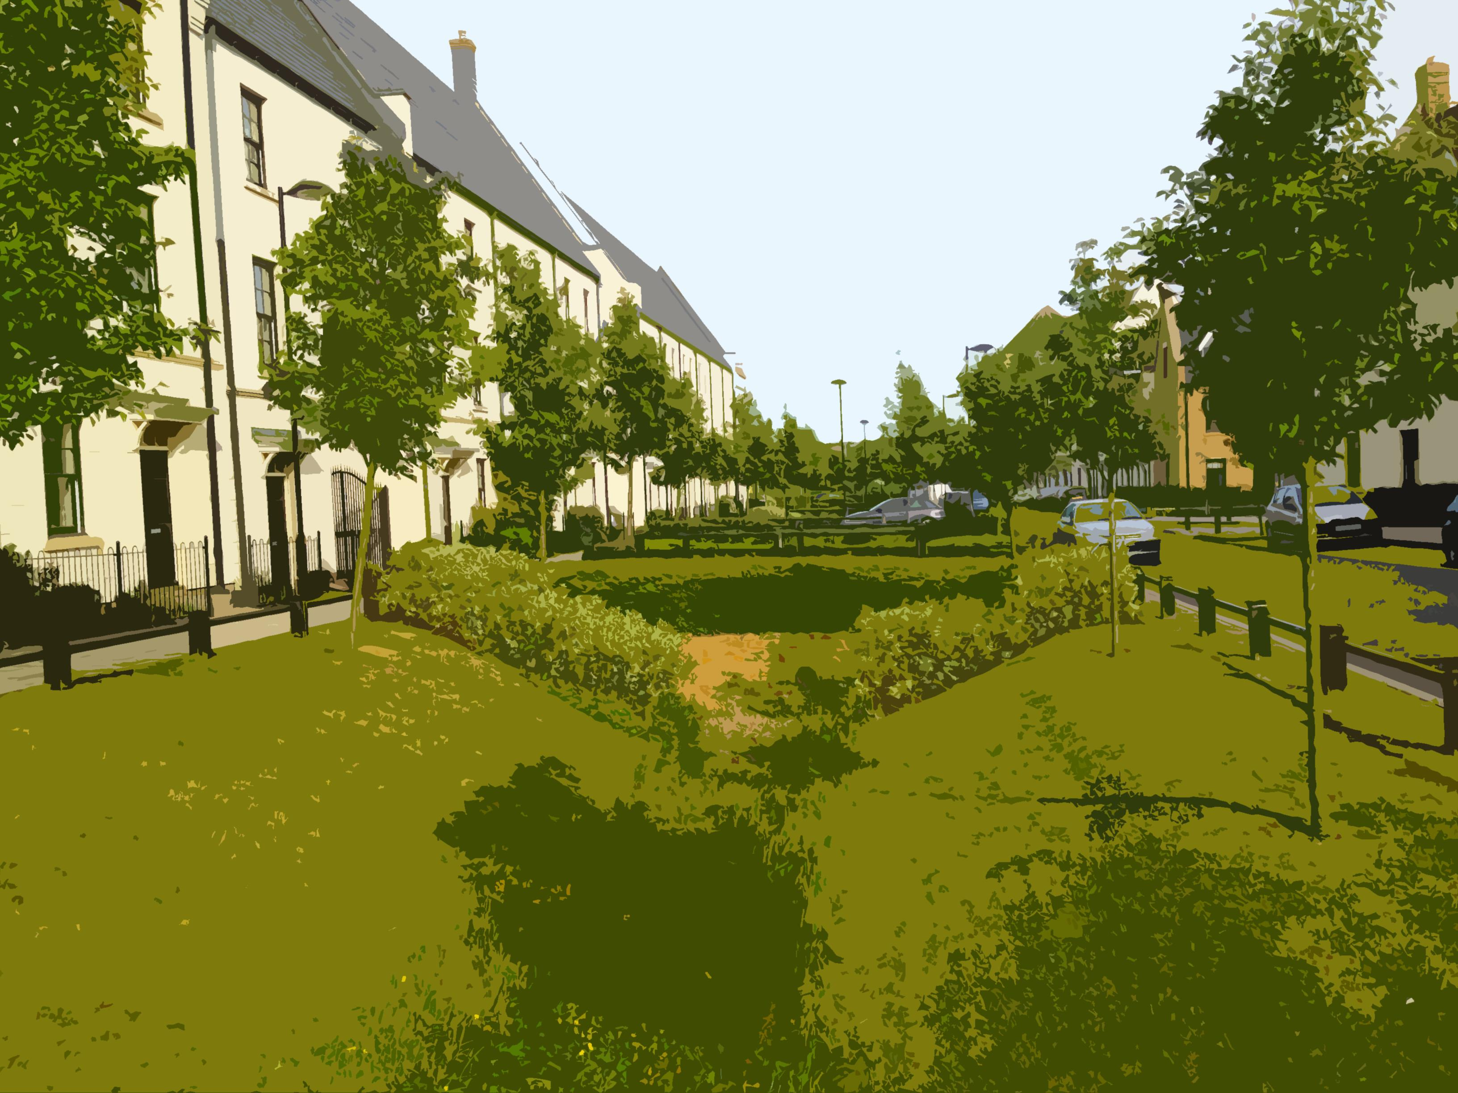

SuDSmart Plus

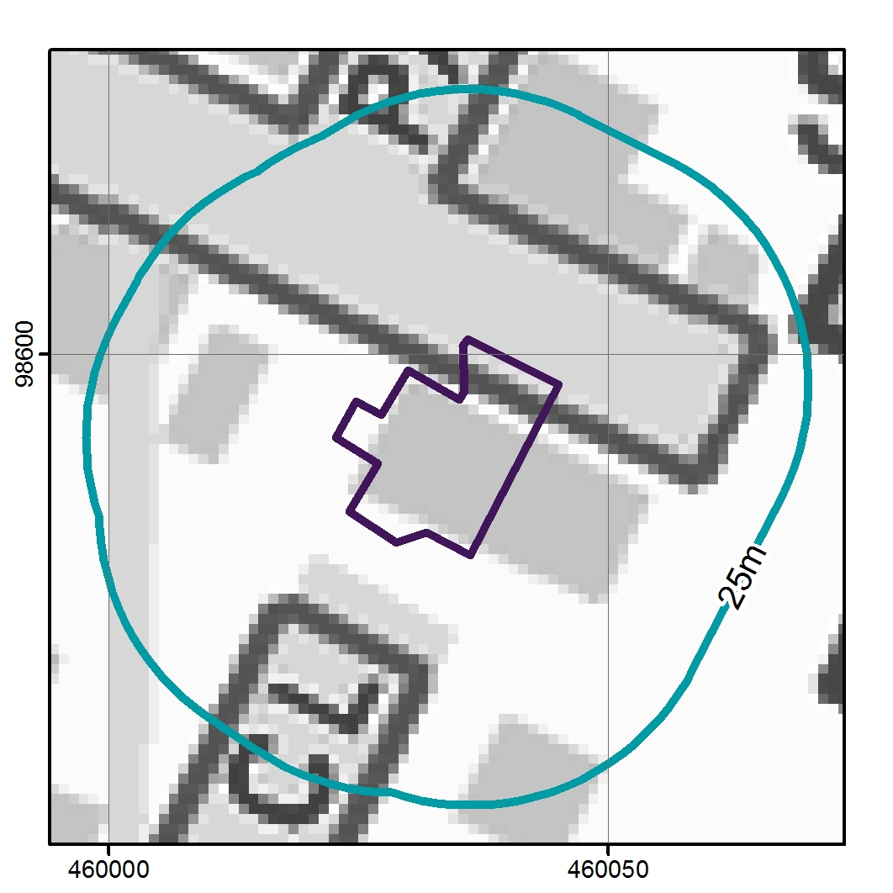

**Report reference: Report status: Date issued:**

**51402 xxx 2017-01-12**

Site address:

Overview:

The preferred SuDs option is infiltration for which there is moderate to high potential. The development potentially increases the run-off volume by 32 m3 for the 1 in 100 year, 6 hour event.

# 1. Executive summary

SuDS suitability

**Comments:** There are a range of SuDS options for the Site. The first option to consider is infiltration for which there is - potential. Alternative options include discharging to surface waters, sewer and highway drain.

|  |  |  |
| --- | --- | --- |
| Risk | Issue | Result |
| SuDS suitability | What is the infiltration potential at the Site? | - |
| What is the potential to discharge to surface water features? | Low |
| What is the potential to discharge to sewers? | Low |
| Flooding | What is the overall flood risk at the Site? | Negligible |
| Pollution | Is the groundwater a protected resource? | No |
| Is the surface water feature a protected resource? | Find protected surface waters - those designated for drinking water abstraction. |

SuDS runoff and volume summary

Suggested infiltration SuDS include: infiltration trenches, soakaways, permeable pavements, rain gardens, swales and retention basins. Supporting calculations are in Section 11.

|  |  |  |
| --- | --- | --- |
| Potential increase in runoff due to the development\*1  Minimum attenuation assuming some off-site discharge. | Total runoff including climate change (+40%)\*1  Maximum attenuation assuming no off-site discharge | Change in impermeable area on a previously developed site  As a % of total area |
| **🡹** +32 m3 | +64 m3 | **🡹** + 50% |

\*1 for the 6 hour, 1 in 100 year event excluding mitigation

Next steps

A Site investigation is required to confirm the infiltration capacity of the ground, the capacity of surface water bodies to accept surface water runoff and whether sewers within the immediate vicinity of the Site could be used within the SuDS design. We recommend a SuDSmart Pro report which will provide the storage volumes required and an outline SuDS Strategy.

**Additional considerations:**

The final design capacity for an infiltration SuDS system depends on the Site constraints and the following assessments are required:

Site topography and drainage routes, confirmation of sufficient depth to the high water table, review of ground stability and minimum soakaway separation from adjacent buildings, confirmation that contaminated land will not constrain infiltration on the Site, flooding constraints in the vicinity of the Site, calculation of runoff rates and volumes and assessment of SuDS options and drainage strategy.

**Environmental and ecological considerations:**

The Site is not located within a Special Protected Area (SPA) or a Site of Special Scientific Interest (SSSI).

**CDM considerations:**

If your development is defined as ‘Construction Work’ under CDM 2015, you or the organisation that is having the work carried out will be defined as ‘the Client’ and have specific duties under the Regulations. A full list of CDM considerations and our Terms and Conditions can be found on our website, the links can be found in section 14 at the back of this report.

2. Site location

**Report prepared on:**

2017-01-12

**Site area:**

**Current use:**

**Proposed use:**

**Report author:**

Michael Piotrowski

**Report reviewer:**

[enter reviewer name]

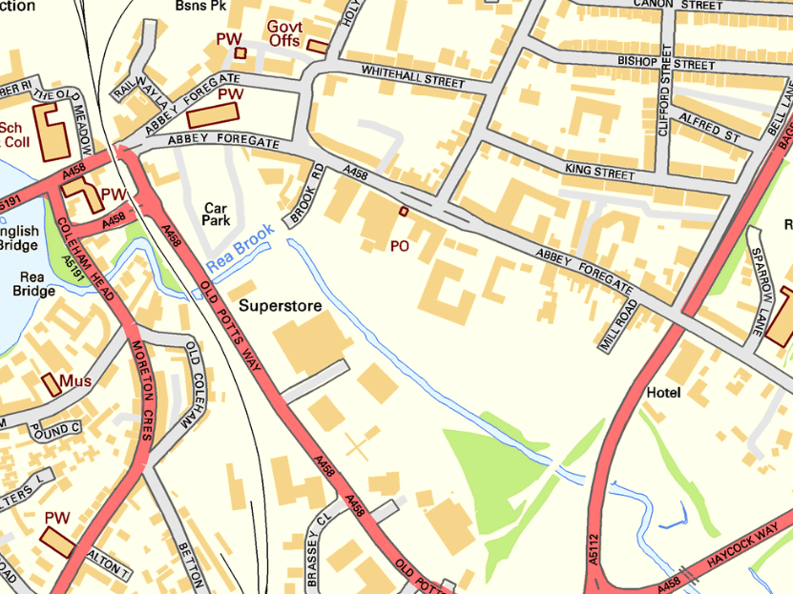

xw

# 

# suds_infiltration_suitability_map_uri3. SuDS infiltration suitability (SD50) map

Contains Ordnance Survey data © Crown copyright and database right 2016

<http://www.nationalarchives.gov.uk/doc/open-government-licence/version/3/>

The GeoSmart SuDS Infiltration Suitability (SD50) Map screens the potential for infiltration drainage at the Site and indicates where further assessment is recommended. Unknown. ESI SuDs data not loaded

The map combines information on the thickness and permeability of the underlying material and the depth to the high groundwater table. It supports conceptual Site drainage design and the planning of further Site investigation. A Site investigation is recommended to investigate groundwater levels and formation thickness and to confirm that infiltration rates at the Site are sufficient to accommodate an infiltration SuDS feature.

# 4. Site topography

Contains Ordnance Survey data © Crown copyright and database right 2016

<http://www.nationalarchives.gov.uk/doc/open-government-licence/version/3/>

GeoSmart have undertaken an assessment of the topography at the Site and within its vicinity, using LiDAR elevation data from the Environment Agency. The mapping shows a comparison between average ground levels on the Site with ground levels in the surrounding area.

Assessment has been undertaken using GIS/OS mapping data as well as interrogation of LiDAR DTM5 elevation data, to identify localized depressions.

Further analysis could be undertaken by visiting the Site or by collecting additional topographic survey to provide further confirmation of ground levels.

# 5. Source protection zone map

# spz_map_uri

Contains Ordnance Survey data © Crown copyright and database right 2016

<http://www.nationalarchives.gov.uk/doc/open-government-licence/version/3/>

GeoSmart have undertaken an assessment of the Environment Agency groundwater Source Protection Zones (SPZ) within the vicinity of the Site.

The site is not within a source protection zone, infiltration to the ground is likely to be acceptable providing suitable mitigation measures are in place if required to prevent an impact on water quality from the proposed or historical land use and contaminated land.

If further analysis is required, this would involve a review of Site specific contaminated land data. If hazards are identified, it is recommended that the Local Authority and the Environment Agency are contacted to confirm the susceptibility of any SPZ’s within the wider area.

# 6. Surface water features map

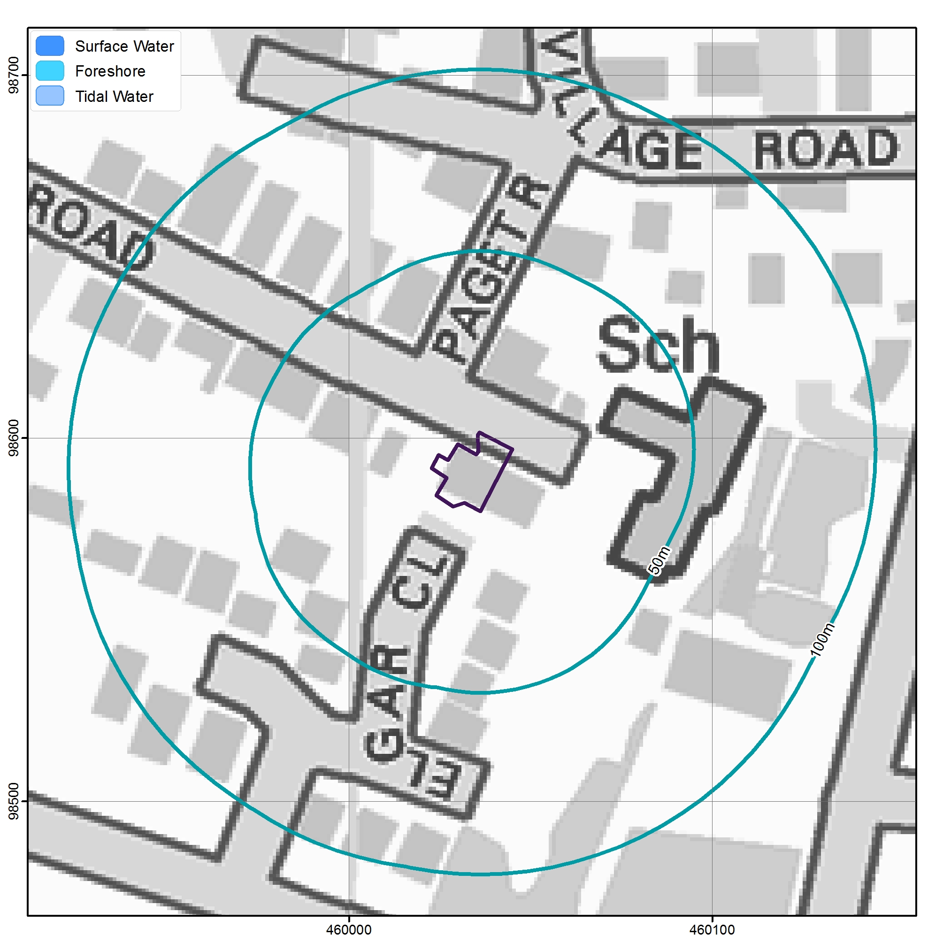

Contains Ordnance Survey data © Crown copyright and database right 2016

<http://www.nationalarchives.gov.uk/doc/open-government-licence/version/3/>

GeoSmart have undertaken an assessment of the location of surface water features within the vicinity of the Site. The site is >100m from a surface water body. Discharge to surface water is unlikely to be appropriate.

The site is not within 250m of a SSSI

Further analysis could be undertaken by visiting the Site or by contacting the Local Council and the Environment Agency to confirm the presence, location and condition of these watercourses.

# 7. Sewer features map

# 

Contains Ordnance Survey data © Crown copyright and database right 2016

<http://www.nationalarchives.gov.uk/doc/open-government-licence/version/3/>

GeoSmart have undertaken an assessment of the location of sewer features within the vicinity of the Site. The site is further than 100m from a sewer. Discharge to sewer is unlikely to be appropriate.

Further analysis of the connections and condition of the public surface water and foul drainage systems should be undertaken by carrying out a CCTV survey, or by contacting the drainage provider or the Local Council to confirm the presence, location and condition of these sewers. Consultation with the drainage provider should be undertaken to ensure permission to connect and to determine that sufficient capacity is available to accept the proposed discharge.

# 8. Risk of flooding from rivers and sea map

# 

Contains Ordnance Survey data © Crown copyright and database right 2016

<http://www.nationalarchives.gov.uk/doc/open-government-licence/version/3/>

GeoSmart have undertaken an assessment of the risk of flooding from the rivers and the sea within the vicinity of the Site.

The site has a negligible risk of fluvial or coastal flooding.

Where there is a moderate or high risk, further analysis could be undertaken by visiting the Site or by contacting the Local council and the Environment Agency to confirm the risk and the associated flood depths.

# 9. Risk of flooding from surface water map

Contains Ordnance Survey data © Crown copyright and database right 2016

<http://www.nationalarchives.gov.uk/doc/open-government-licence/version/3/>

GeoSmart have undertaken an assessment of the risk of flooding from pluvial sources within the vicinity of the Site. The site has a negligible risk of surface water flooding.

Further analysis could be undertaken by visiting the Site or by contacting the Local Council and the Environment Agency; to confirm the pluvial flood risk and flood depths and velocities where applicable.

# groundwater_flood_risk_map_uri10. Groundwater flood risk (GW5) map

Contains Ordnance Survey data © Crown copyright and database right 2016

<http://www.nationalarchives.gov.uk/doc/open-government-licence/version/3/>

The site has a negligible risk of groundwater flooding.

Approximately 30% of the Site has a moderate risk of flooding with a minimum 1% annual probability of flooding from groundwater according to the GeoSmart GW5 map. SuDS design should take account of the potential flooding to ensure an operational system by avoiding flood prone areas and assessing the consequences of flooding on the effective operation of the drainage system.

Approximately 70% of the Site has a low risk of flooding with a minimum 1% annual probability of flooding from groundwater according to the GeoSmart GW5 map. SuDS design is unlikely to be affected in these areas.

Confirmation of sufficient depth to the high water table in areas at moderate risk would be appropriate. A review of ground stability and minimum soakaway separation from adjacent buildings could also be assessed through further Site Investigation.

# 11. Storage, volume and peak flow rate

Suggested minimum and aspirational storage requirements for an infiltration SuDS scheme for the development footprint are set out below with more detail provided in subsequent sections. Storage volumes may be reduced (but not below the minimum level) if the design incorporates off-site discharge.

|  |  |  |
| --- | --- | --- |
| Attenuation scenario | Attenuation requirement (m3) | Explanation |
| Minimum | 32 | Minimum storage required to supplement an existing drainage system (runoff from proposed development minus existing runoff volume for the 6 hour, 1 in 100 year event).  Note: this excludes climate change. |
| Medium | 37 | Storage required assuming no off site drainage so that, unless an area is designated to hold and/or convey water as part of the design, flooding does not occur on any part of the site for up to a 1 in 30 year, 6 hour rainfall event. Controlled flooding of non-essential areas could occur for higher return periods. |
| Maximum | 64 | Storage required assuming no off site drainage for the 6 hour 1 in 100 year event, including the maximum effects of climate change.  Note: discharge off site will reduce this, and the increase as a result of climate change is less for buildings with a limited design life. |

Surface water runoff

An increase in impermeable area on site will result in greater rainfall runoff. Reduction in runoff will help mitigate flood risk both on and off site. Further information on the surface water runoff calculations is provided in Section 6 ‘Background Information’.

Guidance

The Non-Statutory Technical Guidance for SuDS (Defra, March 2015) states:

“Where reasonably practicable, for Greenfield development, the runoff volume from the development to any highway drain, sewer or surface water body in the 1 in 100 year, 6 hour rainfall event should never exceed the Greenfield runoff volume for the same event. Where reasonably practicable, for developments which have been previously developed, the runoff volume from the development to any highway drain, sewer or surface water body in the 1 in 100 year, 6 hour rainfall event must be constrained to a value as close as is reasonably practicable to the Greenfield runoff volume for the same event, but should never exceed the runoff volume from the development site prior to redevelopment for that event.”

Table 1: Change in impermeable area associated with the development

|  |  |
| --- | --- |
| Total site area | 3600 m2 |
| Area that remains unchanged and is excluded from the development footprint drainage and runoff calculations. | 2400 m2 comprising existing building |
| Impermeable area (and as a percentage of the total area of the proposed development footprint of 1200 m2) | |
| Pre-development | Post-development |
| 200 m2 (17%) | 800 m2 (67%) |
| Impermeable Land use:  Commercial office, car park  Permeable Land use:  landscaped areas | New impermeable land use:  600 m2 commercial office extension  New permeable land use:  100 m2 of permeable paving |

Only the area intended for building development has been considered for the calculations. Permeable car parking areas represent no change in impermeable area and are excluded.

*Please note if the report is intended for the extension of an existing building then the area for the report calculations should be based on the proposed extension area.*

Guidance

“The drainage system must be designed so that, unless an area is designated to hold and/or convey water as part of the design, flooding does not occur on any part of the site for a 1 in 30 year rainfall event’ and ‘flooding does not occur during a 1 in 100 year rainfall event in any part of: a building (including a basement); or in any utility plant susceptible to water (e.g. pumping station or electricity substation) within the development”

(Defra, March 2015, non-statutory guidance).

Peak discharge rates

The table below presents peak discharge rates for a range of storm events used to assess the impact of the proposed development and select the maximum permitted discharge rate. Further information on the calculation and control of peak discharge rates is provided in Section 6 ‘Background Information’.

Table 2: Peak discharge rates associated with the development

|  |  |  |  |  |
| --- | --- | --- | --- | --- |
| Rainfall event | Greenfield runoff rates | Existing  runoff rates1 (l/s) | Potential  runoff rates without attenuation | Potential minus  existing (l/s) |
| QBAR | 0.02 |  |  |  |
| 6 hour 1 in 1 year | 0.02 | 0.2 | 0.6 | 0.4 |
| 6 hour 1 in 10 year | 0.03 | 0.5 | 1.3 | 0.8 |
| 6 hour 1 in 30 year | 0.04 | 0.6 | 1.7 | 1.1 |
| 6 hour 1 in 100 year | 0.06 | 0.8 | 2.3 | 1.5 |
| 6 hour 1 in 100 year + 20% CC |  |  | 2.7 | 1.9 |
| 6 hour 1 in 100 year + 40% CC |  |  | 3.0 | 2.2 |

1 Assumes 100% runoff from impermeable surfaces. Assumes Greenfield runoff from permeable surfaces calculated using the IoH124 method.

Relevant local and regional plan policy should be consulted to determine restrictions on runoff from previously developed sites. In some cases greenfield rates may be requested. In practice it is difficult to restrict discharge rates at any one control point to less than 5 l/s.

Total discharge volumes

The table below presents discharge volumes for a range of storm events used to assess the impact of the proposed development and calculate the required storage volumes. Further information on the calculation of total discharge volumes is provided in Section 6 ‘Background Information’.

Table 3: Total discharge volumes associated with the development

|  |  |  |  |  |
| --- | --- | --- | --- | --- |
| Rainfall event | Greenfield runoff volume (m3) | Existing  runoff volume2 (m3) | Potential runoff volume without attenuation (m3) | Potential minus  existing (m3) |
| QBAR | 2 |  |  |  |
| 6 hour 1 in 1 year | 2 | 4 | 12 | 8 |
| 6 hour 1 in 10 year | 4 | 10 | 28 | 18 |
| 6 hour 1 in 30 year | 5 | 13 | 37 | 24 |
| 6 hour 1 in 100 year | 7 | 18 | 49 | 32 |
| 6 hour 1 in 100 year + 20% CC |  |  | 59 | 42 |
| 6 hour 1 in 100 year + 40% CC |  |  | 64 | 47 |

2 Assumes 100% runoff from impermeable surfaces. Assumes Greenfield runoff from permeable surfaces calculated using the IoH124 method.

Climate change

Projections of future climate change, in the UK, indicate more frequent, short-duration, high-intensity rainfall and more frequent periods of long duration rainfall. Guidance included within the National Planning Policy Framework (NPPF) recommends that the effects of climate change are incorporated into Flood Risk Assessments (NPPF technical guidance note, DCLG, 2012).

Updated guidance (March 2016) on climate change recommends that both the 20% Central Allowance and 40% Upper End allowances should be added to the peak rainfall intensity for residential or commercial development, to understand the range of impacts. Where feasible, a precautionary approach should be taken particularly in areas at risk of flooding.

Table 4: Peak rainfall intensity allowance in small and urban catchments (use 1961 to 1990 baseline)

|  |  |  |  |
| --- | --- | --- | --- |
| Applies across all of England | Total potential change anticipated for the ‘2020s’ (2015 to 2039) | Total potential change anticipated for the ‘2050s’ (2040 to 2069) | Total potential change anticipated for the ‘2080s’ (2070 to 2115) |
| Upper End | 10% | 20% | +40% |
| Central | 5% | 10% | +20% |

# 12. Methodology and limitations of study

This report assesses the feasibility of infiltration SuDS and alternative drainage strategies in support of the Site development process. From April 6th 2015 SuDS are regulated by Local Planning Authorities and will be required under law for major developments in all cases unless demonstrated to be inappropriate. What is considered appropriate in terms of costs and benefits by the Planning Authority will vary depending on local planning policy, and Site setting. The Lead Local Flood Authority will require information as a statutory consultee on major planning applications with surface water drainage implications. The National Planning Policy Framework requires that new developments in areas at risk of flooding should give priority to the use of SuDS and demonstrate that the proposed development does not increase flood risk downstream to third parties.

How was the suitability of SuDS estimated for the Site?

There are a range of SuDS options available to provide effective surface water management that intercept and store excess runoff. When considering these options, the destination of the runoff should be assessed using the order of preference outlined in the Building Regulations Part H document (HM Government, 2010) and Defra’s Draft National Standards for SuDS (2011):

1. Discharge to the ground;
2. Discharge to a surface water body;
3. Discharge to a surface water sewer;
4. Discharge to a local highway drain; and
5. Discharge to a combined sewer.

Data sets relating to each of the potential discharge options have been analysed to assess the feasibility of each option according to the hierarchy set out above. Hydrogeological characteristics for the Site are assessed in conjunction with the occurrence of SPZ’s to assess infiltration suitability. The Site has been screened to determine whether flood risk from groundwater, surface water, fluvial or coastal sources may constrain SuDs. The distance to surface water bodies and sewers has been reviewed gauge whether these provide alternative options.

GeoSmart SuDS Infiltration Suitability Map (SD50)

The GeoSmart SuDS Infiltration Suitability Map (SD50) screens the suitability for infiltration drainage in different parts of the Site and indicates where further assessment is recommended. In producing the SuDS Infiltration Suitability Map (SD50), GeoSmart used data from the British Geological Survey on groundwater levels, geology and permeability to screen for areas where infiltration SuDS may be suitable. The map classifies areas into 3 categories of High, Medium and Low suitability for infiltration SuDS. This can then be used in conjunction with additional data on Site constraints to give recommendations for SuDS design and further investigation.

The primary constraint on infiltration potential is the minimum permeability of the underlying material and in some cases the range in permeability may be considerable, ranging down to low. The map classifies these areas as moderate infiltration suitability requiring further investigation. In cases where the thickness of the receiving permeable horizon is less than 1.5 meters then additional Site investigation is recommended. If the Site is at risk of groundwater flooding for up to the 1% annual occurrence the map classifies these areas as moderate infiltration suitability requiring further investigation.

The GeoSmart SuDS Infiltration Suitability Map (SD50) is a national screening tool for infiltration SuDS techniques but a Site specific assessment should be used before final detailed design is undertaken. Further information on the GeoSmart SuDS Infiltration Suitability Map (SD50) is available at geosmartinfo.co.uk

How is the suitability to discharge to sewers and watercourses calculated?

The suitability to discharge to discharge to sewers and watercourses has been calculated using the distance from the Site to both. For example, where the Site is within 50m of a surface water body. Discharge to surface water is potentially appropriate subject to land access arrangements and a feasibility assessment. Where the Site is within 50m of a sewer, discharge to sewer is potentially appropriate subject to land access arrangements and a feasibility assessment. The utility company should be contacted to agree connection feasibility and sewer capacity.

Further information relating to sewers available in the area can be found in Appendix A in Section 12 of this report.

What is a Source Protection Zone?  
The Environment Agency have defined Source Protection Zones (SPZs) for 2000 groundwater sources such as wells, boreholes and springs used for public drinking water supply. These zones show the risk of contamination from any activities that might cause pollution in the area. The closer the activity, the greater the risk. The maps show three main zones (inner, outer and total catchment) and a fourth zone of special interest, which is occasionally applied. The zones are used to set up pollution prevention measures in areas which are at a higher risk. The shape and size of a zone depends on the condition of the ground, how the groundwater is removed, and other environmental factors. Inner zone (Zone 1) is defined as the 50 day travel time from any point below the water table to the source (minimum radius of 50 metres). Outer zone (Zone 2) is defined by a 400 day travel time. Total catchment (Zone 3) is defined as the area around a source within which all groundwater recharge is presumed to be discharged at the source.

# 13. Background SuDS information

SuDS control surface water runoff close to where it falls. SuDS are designed to replicate, as closely as possible, the natural drainage from the Site before development to ensure that the flood risk downstream does not increase as a result of the Site being developed, and that the Site will have satisfactory drainage under current and likely future climatic conditions. SuDS provide opportunities to reduce the causes and impacts of flooding; remove pollutants from urban runoff at source; and combine water management with green space with benefits for amenity, recreation and wildlife. Government planning policy and planning decisions now include a presumption in favour of SuDS being used for all development Sites, unless they can be shown to be inappropriate.

For general information on SuDS see our web site: <http://geosmartinfo.co.uk/>

SuDS maintenance and adoption

Regular maintenance is essential to ensure effective operation of the soakaway(s) over the intended lifespan of the proposed development. A maintenance schedule for SuDs is required. Sewerage undertakers or Local Authorities may adopt SuDS and will require maintenance issues to be dealt with in accordance with their Management Plan. If the SuDS will not be adopted other provision is required with associated financial implications. Maintenance is a long-term obligation requiring the upkeep of all elements of the SuDS, including mechanical components (e.g. pumps), as well as inspections, regular maintenance and repair.

Additional background SuDS information can be found on our website. A brief description of Site factors that control suitability infiltration SuDS can be found below:

Geology, permeability and thickness

Multiple geological formations could underlie the Site and each is likely to have a range of permeability and thickness. This can only be confirmed by Site specific data and Site investigation and testing if required. The soil infiltration coefficient must be sufficient to accommodate the required constraints on the dimensions of the soakaway and its emptying time. The underlying material should be confirmed to ensure sufficient thickness to accept infiltration SuDS.

Depth to groundwater

The borehole records should be investigated to confirm water strikes during drilling to a maximum depth. The base of the infiltration system needs to be at least 1m above the expected seasonal high water table. Passage through unsaturated soil is important for improving the quality of infiltrating water before it reaches the water table. The infiltration system should be designed to operate in periods of extreme groundwater levels, therefore the seasonal variance in local groundwater levels should be considered (if available) when finalising a drainage scheme.

Ground conditions

A Site specific review of underlying ground conditions is recommended to ensure focused infiltration does not cause ground instability as a result of landslide or collapse associated with dissolution or shallow mining. Hazards that should be considered include soluble rocks, landslides, compressible ground, collapsible ground, shrink-swell clays, running sand and shallow mining.

Soakaways should be a minimum of 5m away from the foundations of a building and local guidance may recommend a greater distance, such as 10m on some areas of the Chalk. A detailed ground assessment is recommended: on steep slopes where infiltrating water would produce saturation and instability downslope; or within layered geology, where infiltrating water would produce springs down gradient.

Further investigation of the impact of infiltration is considered unlikely to be required at this Site.

Water quality

The influence of surface runoff on water quality will depend on whether there is a source of contamination on Site and the sensitivity of the receiving environment, either groundwater or surface water. The intervening pathway from source to receptor including mitigation and natural attenuation will determine the final impact. Where a Site is located within a source protection zone; a water quality risk assessment could potentially be required. Previously developed Sites may contain contaminated material which could limit the use of infiltration SuDS. Consult the Local Authority and examine historical land uses for an early indication of the likelihood of contamination.

The impact of contaminants on the groundwater will be reduced by travel and natural attenuation through the unsaturated soil zone. A greater depth of unsaturated zone and the presence of significant clay and organic material will provide greater protection for the underlying groundwater. Rapid flow through fractures will provide less protection than intergranular flow around soil and rock particles.

Infiltration systems should not be used where there is a risk of contaminating groundwater by infiltrating polluted runoff or where receiving groundwater is particularly sensitive. In this case an assessment of the quality of infiltrating runoff and the possibilities for pre-treatment may be required.

A key requirement of any SuDS system is that it protects the receiving water body from the risk of pollution. This can be effectively managed by an appropriate “train” or sequence of SuDS components that are connected in series. The frequent and short duration rainfall events are those that are mostly loaded with potential contaminants (silts, fines, heavy metals and various organic and inorganic contaminants). Therefore, the first 5-10 mm of rainfall (first flush) should be adequately treated with SuDS.

The minimum number of treatment stages generally ranges from 1 to 3 and will depend of the sensitivity of the receiving water body and the potential hazard associated with the proposed development as discussed in the SuDS Manual (CIRIA, 2015). For example roof runoff has a low hazard whereas industrial areas may present a high hazard.

# 14. References and glossary

British Geological Survey (BGS), (2015).   
Geology of Britain Viewer. Based on British Geological Survey materials © NERC 2015.  
(http://mapapps.bgs.ac.uk/geologyofbritain/home.html). Last accessed 20/12/2016.

Building Research Establishment (BRE) (1991)   
Digest 365, Soakaway design.

CIRIA (2015) The SuDS manual (C753).

Department for Environment, Food and Rural Affairs (2015)   
Non-statutory technical standards for SuDS (March 2015).

Department for Communities and Local Government. (2006).   
Planning Policy Statement 25: Development and Flood Risk (PPS25).

Department for Communities and Local Government (2012).   
National Planning Policy Framework (NPPF).

Department for Communities and Local Government (2014).   
National Planning Policy Guidance (NPPG).

Environment Agency (2015) What’s in my backyard?   
(http://apps.environment-agency.gov.uk/wiyby/default.aspx). Last Accessed 18/05/2015.

GeoSmart (2016) GeoSmart GW5 Version 2.1.

GeoSmart (2016) GeoSmart Site Investigation Report.

HM Government (2010)   
The building regulations 2010 Part H drainage and waste disposal (2015 edition).

JBCD Associates (2015): Report On Ground Investigation. Ref: 52303A. February 2015.

LASOO (2015) Practice Guidance, Local Authority SuDS Officer Organisation.

NERC (2009) WINFAP-FEH CD-ROM version 3.0.

CEH (2016) Online FEH web service Depth/duration/frequency modelling using the FEH 1999 and new 2013 models (<https://fehweb.ceh.ac.uk/>) Last accessed on 20/12/2016.

|  |  |
| --- | --- |
| Glossary**3** | |
| Attenuation | Reduction of peak flow and increased duration of a flow event. |
| Combined sewer | A sewer designed to carry foul sewage and surface water in the same pipe. |
| Detention basin | A vegetated depression, normally is dry except after storm events, constructed to store water temporarily to attenuate flows. May allow infiltration of water to the ground. |
| Evapotranspiration | The process by which the Earth’s surface or soil loses moisture by evaporation of water and by uptake and then transpiration from plants. |
| FEH | Flood Estimation Handbook, produced by Centre for Ecology and Hydrology, Wallingford (formerly the Institute of Hydrology). |
| Filter drain or trench | A linear drain consisting of a trench filled with a permeable material, often with a perforated pipe in the base of the trench to assist drainage, to store and conduct water, but may also be designed to permit infiltration. |
| First flush | The initial runoff from a site or catchment following the start of a rainfall event. As runoff travels over a catchment it will collect or dissolve pollutants, and the “first flush” portion of the flow may be the most contaminated as a result. This is especially the case for intense storms and in small or more uniform catchments. In larger or more complex catchments pollution. |
| Flood plain | Land adjacent to a watercourse that would be subject to repeated flooding under natural conditions (see Environment Agency’s Policy and practice for the protection of flood plains for a fuller definition). |
| Greenfield runoff | This is the surface water runoff regime from a site before development, or the existing site conditions for brownfield redevelopment sites. |
| Impermeable surface | An artificial non-porous surface that generates a surface water runoff after rainfall. |
| Permeability | A measure of the ease with which a fluid can flow through a porous medium. It depends on the physical properties of the medium, for example grain size, porosity and pore shape. |
| Runoff | Water flow over the ground surface to the drainage system. This occurs if the ground is impermeable, is saturated or if rainfall is particularly intense. |
| Sewerage undertaker | This is a collective term relating to the statutory undertaking of water companies that are responsible for sewerage and sewage disposal including surface water from roofs and yards of premises. |
| Soakaway | A subsurface structure into which surface water is conveyed to allow infiltration into the ground. |
| Treatment | Improving the quality of water by physical, chemical and/or biological means. |

# 15. Further information

Disclaimer

This report has been prepared by GeoSmart in its professional capacity as soil and groundwater specialists, with reasonable skill, care and diligence within the agreed scope and terms of contract and taking account of the manpower and resources devoted to it by agreement with its client, and is provided by GeoSmart solely for the internal use of its client.

The advice and opinions in this report should be read and relied on only in the context of the report as a whole, taking account of the terms of reference agreed with the client. The findings are based on the information made available to GeoSmart at the date of the report (and will have been assumed to be correct) and on current UK standards, codes, technology and practices as at that time. They do not purport to include any manner of legal advice or opinion. New information or changes in conditions and regulatory requirements may occur in future, which will change the conclusions presented here.

This report is confidential to the client. The client may submit the report to regulatory bodies, where appropriate. Should the client wish to release this report to any other third party for that party’s reliance, GeoSmart may, by prior written agreement, agree to such release, provided that it is acknowledged that GeoSmart accepts no responsibility of any nature to any third party to whom this report or any part thereof is made known. GeoSmart accepts no responsibility for any loss or damage incurred as a result, and the third party does not acquire any rights whatsoever, contractual or otherwise, against GeoSmart except as expressly agreed with GeoSmart in writing.

Further information

Information on confidence levels and ways to improve this report can be provided for any location on written request to info@geosmart.co.uk or via our website. Updates to our model are ongoing and additional information is being collated from several sources to improve the database and allow increased confidence in the findings. Further information on groundwater levels and flooding are being incorporated in the model to enable improved accuracy to be achieved in future versions of the map. Please contact us if you would like to join our User Group and help with feedback on infiltration SuDS and mapping suggestion.

Important consumer protection information

This search has been produced by GeoSmart Information Limited, New Zealand House, 160-162 Abbey Foregate, Shrewsbury, SY2 6FD.

Tel: 01743 276150

Email: info@geosmartinfo.co.uk

GeoSmart Information Ltd is registered with the Property Codes Compliance Board (PCCB) as a subscriber to the Search Code. The PCCB independently monitors how registered search firms maintain compliance with the Code.

The Search Code:

* provides protection for homebuyers, sellers, estate agents, conveyancers and mortgage lenders who rely on the information included in property search reports undertaken by subscribers on residential and commercial property within the United Kingdom
* sets out minimum standards which firms compiling and selling search reports have to meet
* promotes the best practice and quality standards within the industry for the benefit of consumers and property professionals
* enables consumers and property professionals to have confidence in firms which subscribe to the code, their products and services.
* by giving you this information, the search firm is confirming that they keep to the principles of the Code. This provides important protection for you.

The Code’s core principles

Firms which subscribe to the Search Code will:

* display the Search Code logo prominently on their search reports
* act with integrity and carry out work with due skill, care and diligence
* at all times maintain adequate and appropriate insurance to protect consumers
* conduct business in an honest, fair and professional manner
* handle complaints speedily and fairly
* ensure that products and services comply with industry registration rules and standards and relevant laws
* monitor their compliance with the Code

Complaints

If you have a query or complaint about your search, you should raise it directly with the search firm, and if appropriate ask for any complaint to be considered under their formal internal complaints procedure. If you remain dissatisfied with the firm’s final response, after your complaint has been formally considered, or if the firm has exceeded the response timescales, you may refer your complaint for consideration under The Property Ombudsman scheme (TPOs). The Ombudsman can award compensation of up to £5,000 to you if he finds that you have suffered actual loss as a result of your search provider failing to keep to the Code.

Please note that all queries or complaints regarding your search should be directed to your search provider in the first instance, not to TPOs or to the PCCB.

TPOs contact details:

The Property Ombudsman scheme

Milford House

43-55 Milford Street

Salisbury

Wiltshire SP1 2BP

Tel: 01722 333306

Fax: 01722 332296

Email: admin@tpos.co.uk

You can get more information about the PCCB from [www.propertycodes.org.uk](http://www.propertycodes.org.uk).

Please ask your search provider if you would like a copy of the search code

Complaints procedure

GeoSmart Information Limited is registered with the Property Codes Compliance Board as a subscriber to the Search Code. A key commitment under the Code is that firms will handle any complaints both speedily and fairly.

If you want to make a complaint, we will:

* Acknowledge it within 5 working days of receipt.
* Normally deal with it fully and provide a final response, in writing, within 20 working days of receipt.
* Keep you informed by letter, telephone or e-mail, as you prefer, if we need more time.
* Provide a final response, in writing, at the latest within 40 working days of receipt.
* Liaise, at your request, with anyone acting formally on your behalf.

If you are not satisfied with our final response, or if we exceed the response timescales, you may refer the complaint to The Property Ombudsman scheme (TPOs): Tel: 01722 333306, E-mail: [admin@tpos.co.uk](mailto:admin@tpos.co.uk).

We will co-operate fully with the Ombudsman during an investigation and comply with his final decision.

Complaints should be sent to:

Jemma Prydderch

Operations Manager

GeoSmart Information Limited

New Zealand House

160 Abbey Foregate

Shrewsbury

SY2 6FD

Tel: 01743 276150

jemmaprydderch@geosmartinfo.co.uk

# 16. Terms and conditions, CDM regulations and data limitations

# Terms and conditions can be found on our website: <http://geosmartinfo.co.uk/terms-conditions/>

CDM regulations can be found on our website: <http://geosmartinfo.co.uk/knowledge-hub/cdm-2015/>

Data use and limitations can be found on our website: <http://geosmartinfo.co.uk/data-limitations/>

# 17. Appendices

# Appendix A

Existing and proposed Site plans (layout and topography)

# Appendix B

Rainfall runoff calculations